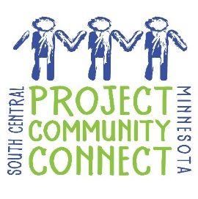
Registration for
Project Community Connect
April 18, 2017
12:00 p.m. – 4:00 p.m.
Verizon Wireless Center
(1 Civic Center Plaza, Mankato, MN)

The South Central area for this event covers nine counties (Blue Earth, Brown, Faribault, Le Sueur, Martin, Nicollet, Sibley, Waseca, and Watonwan). Please bring referral materials for your agency providers in these counties.

(Please Fill Out Completely)

Organization Name: ________________________________________________________________________
Contact Person: ____________________________________________________________________________
Address: _________________________________________________________________________________
Phone: _____________________________________ Email: _______________________________________
2 lunches provided with booth fee. Number of additional lunches needed ($5.00 each): __________________

Briefly describe what services you will offer during Project Community Connect.
___________________________________________________________________________________________________________________________________________________________________________________________________________________________________________________________________________

Providers will be organized into service sectors. In which service sector would you prefer to be located?
- Housing Employment Dental, Medical Health
- Legal Children/Youth Social Service Agency
- Social Security Education Mental Health/Chemical Dependency
- Food Veterans

Each provider will be allotted 1 table and 2-4 chairs for staff and guests. Every effort will be made to provide you with all your needs; however, we cannot guarantee all needs will be met. Please indicate only those needs that are required to provide your services.
Electrical hookup Yes No
Other needs Yes No If yes, please specify:_______________________________

This event runs from 12:00 p.m. to 4:00 p.m. Provider booths should be set up by 11:30 a.m. In fairness to participants who will come in throughout the day, providers are requested to have their tables staffed for the entire event. Agencies who stay for the entire event will be entered into a drawing to win a free booth space for Project Community Connect 2018.

Fee is $35.00 per booth. Fee includes 1 table, 2-4 chairs for staff and guests, and 2 lunches (additional lunches $5.00 each). Please mail this form and the fee (check payable to United Way) by March 24, 2017, to:
Laura Murray
127 S. 2nd St. #190
Mankato, MN 56001

